

Tower Trophy
Challenge
2007

Sunday 27th MAY

At

Riddell Estate Nr. Lilliesleaf

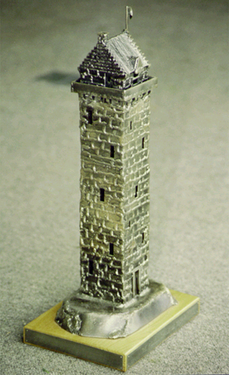

INFORMATION PACK

General Information

Welcome to the Tower Trophy Challenge and thank you for taking part. Please read the following instructions carefully and pass them on to all of your team members. If you have any queries or require further information then please contact any of the people below. We hope you have a very enjoyable and exciting day, oh one more thing-
Best of luck!!!!

Main Co-ordinator Other Co-ordinators

Nancy Anderson Jim Shepherd
Mosspark Tel 07789233504
West Morriston
Earlston Allan McGee
TD4 6AZ Tel 01450 376996
Tel 01896 849362
Mobile 0779 222 1449

Email nancy-haggis@tiscali.co.uk Andrew Grant
Tel 01835 870309
GENERAL INFORMATION

The objective of the Tower Trophy Challenge is to raise awareness of the Borders Exploration Group and the opportunities it can bring to young people in the Borders. It is hoped that this will generate some much-needed funds to support the very worthwhile work carried out by the group.

To enter you require:

- A team of 8 participants (over 18 years old) who are of reasonable fitness containing at least 2 members of the opposite sex.
- A team manager who will form part of the team but will also act as the team co-ordinator (see team managers responsibilities).
- Team manager, or representative, to attend meeting prior to the event on Wednesday 9th May at 8.00pm at Riddell Estate.
- The team must raise a minimum of £160 (£20 per head paid at time of registration)
- In addition teams are invited to increase their donation to Borders Exploration Group via sponsorship
- To bring along on the day a sense of humour, variety of skills and loads of team spirit

All teams will compete for the prestigious Tower Trophy, which will be awarded to the winning team, and a bottle of wine will be given to each team member. Brains and brawn are important but so is the ability and commitment to raise as much money for the Borders Exploration Group. In recognition of this, the team that raises the most money will receive a scaled down replica of the Tower Trophy and each team member a bottle of wine, along with the Sponsorship Shield presented to the team.

This event has now been running for a number of years and has proved enormously successful. It is run with the assistance and kind permission or Mr and Mrs Andrew Grant, Riddell Estate, Lilliesleaf.

Amongst previous winners are:
- The Media Team
- Tweed Valley Mountain Rescue
- Earlston High School
- Borders Health Team
- Ecodyn
Other Requirements

We require your team to be clearly identified during the entire event. Each team must therefore provide identical bandanas in the colour ……………… and have with them a stuffed mascot of not less than 3ft that must be carried with them at all times. Each team member is required to be dressed in camouflage.

All team members must have a reasonable level of fitness – it is not however a requirement to be “super fit”. Many of the events will require a sharp mind coupled with a determined attitude rather than relying on purely physical attributes. The organisers must be informed of team members who have any medical conditions/requirements. This information should be conveyed by the team manager to the organisers and will be held in confidence. Form B attached must be completed by all team members and carried at all times throughout the event.

The team will be required to arrive at Riddell Estate between 8.00-8.10am for a briefing at 8.30am. Please do not be late as a prompt start is essential for the smooth running of the entire day.

Riddell Estate is situated on the B6400 west of Lilliesleaf, Grid Ref 517 246 Landranger Map73
Kit List

Per Individual

- Waterproof trousers and Jacket

- Walking boots which must be worn all day – no trainers

- Complete change of clothes

- Packed lunch

- Sweets for energy on route

- 1 Litre of water

- Rucksack to carry your kit for the entire day

- Compass

- Pen and Note Pad

- Plastic bags

- Small first aid kit

- Survival Bag

Team Manager’s Responsibilities

The Team Manager will be responsible for:

- Attending managers meeting on Wed 9th May at Riddell Estate
- Team selection.
- Ensuring he/she is fully conversant with all the requirements.
- Distributing all the information to the team members.
- Ensuring their team all have bandanas and the mascot
- Maintaining team discipline.
- Monitoring team welfare during the event.
- Team motivation.
- Ensuring prompt arrival of their team on the day.
- Photocopying the sponsor form and distributing it to all members
- Ensuring that all money raised is forwarded to the organisers. Amount pledged must be indicated at registration at the beginning of the day to allow for presentation of the sponsorship shield
- Ensuring completion of form B ( Medical form)
- Ensuring team members have full kit.

